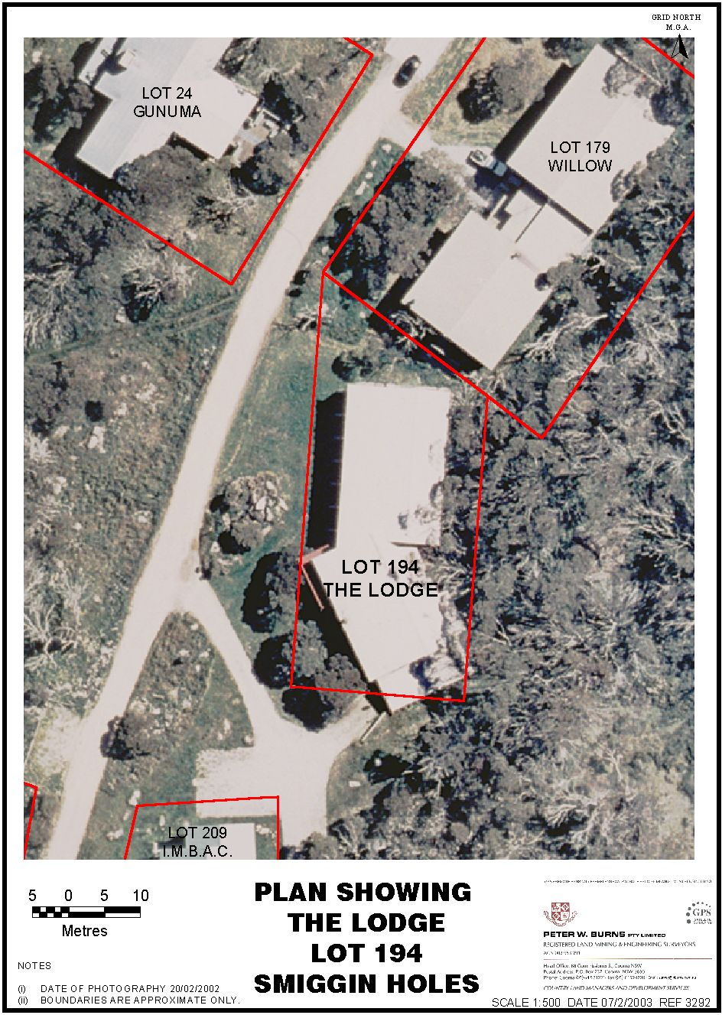
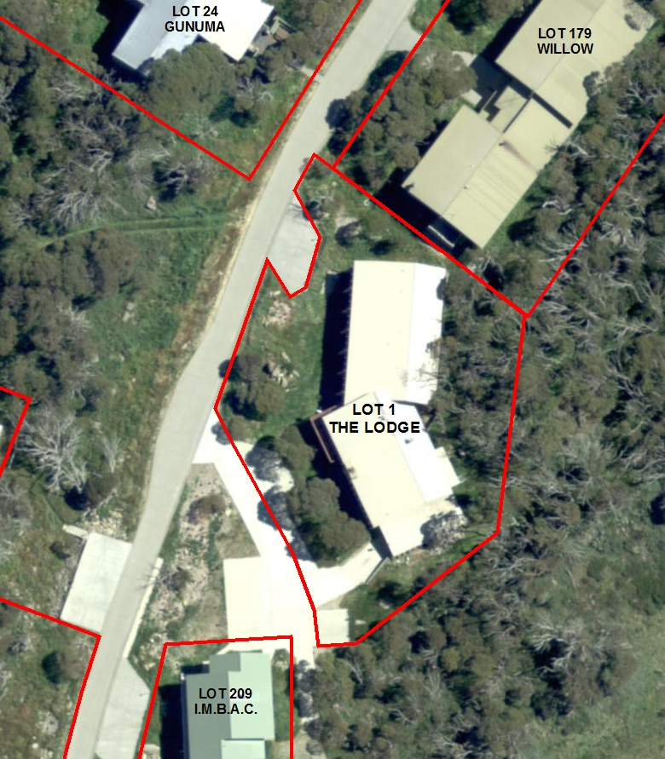


Premises Access
Adjoining Premises Access
Shared
Access
Car
Parking
Encroachment
Licensed
Area
Legend

PLAN SHOWING
THE LODGE
LOT 1
SMIGGIN HOLES

